PRESS RELEASE – For immediate release
China & South Africa could be the next frontiers for shea-based products, study suggests
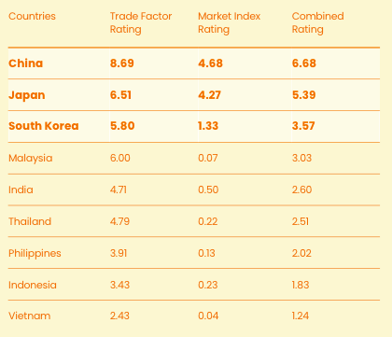
Accra, Ghana – 10 November, 2020
A study commissioned by the Global Shea Alliance (GSA) has identified the most promising export markets in Africa and Asia for West African shea exporters, including for those from Benin, Burkina Faso, Mali and Togo.
The findings will help the shea sector in West Africa direct their attentions to markets with potential, in the hopes of boosting the West Africa shea sector and the incomes of those who harvest shea.
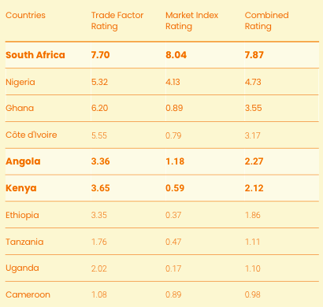
The study, undertaken by the international consulting firm Partnership for Natural Ingredients (PNI), is part of the regional program “Supporting the Inclusive Commercial Development of the Shea Value Chain” (PRADCIFK), supported by the Enhanced Integrated Framework (EIF).
The study, conducted in two parts, evaluates the commercial viability for shea in select markets based on supply and demand factors. A market index analysis was then introduced to determine the scale of potential target consumers and businesses based on specific demographic factors and other market attributes. The study focused on the identification and prioritization of personal care markets to best align with the products sold by PRADCIFK project beneficiaries.
The study found that the most promising markets for the export of shea and related finished products are China, Japan, South Korea, South Africa, Angola and Kenya.
According to Simballa Sylla, President of the Global Shea Alliance, ''This study provides important insights in terms of trade information, and export rules and regulations in several markets in both Africa and Asia. PRADCIFK offers industry players, more specifically MSMEs looking for new markets, a unique avenue to take advantage of the best opportunities for the growth of their business.''
Following the study’s findings, PRADCIFK will support 120 West African brands and retailers to participate in 10 African cosmetics fairs, and 60 West African brands and retailers to participate in six cosmetic fairs in Asia.
NOTES TO EDITORS:
The Global Shea Alliance (GSA) is a non-profit industry association with 560 members from 35 countries including women’s groups, brands and retailers, ingredient suppliers, and NGOs. Through public-private partnerships, the GSA promotes industry sustainability, quality practices and standards, and demand for shea in food and cosmetics. www.globalshea.com
The Enhanced Integrated Framework (EIF) is the only multilateral partnership dedicated exclusively to assisting least developed countries (LDCs) in their use of trade as an engine for growth, sustainable development and poverty reduction. The EIF partnership of 51 countries, 24 donors and 8 partner agencies work closely with governments, development organizations, civil society and academia. Together we leverage our collective know-how, reach and reputation to tackle the world’s most pressing trade-for-development issues. www.enhancedif.org
Press Contact:
Sally Deffor – Communications Manager – Global Shea Alliance
E : sdeffor@globalshea.com

